Windows Application Automation

Contents

A. Installation 1

1. WhiteLibrary 1

2. SikuliLibrary 2

1. AppiumLibrary 2

# Installation

## 1. WhiteLibrary

Step 1: In an existing or new python project, open Terminal and execute following command:

pip install --upgrade robotframework-whitelibrary

Step 2: Verify installed packages in Files > Settings: pythonnet, robotframework (if not) and robotframework-whitelibrary.

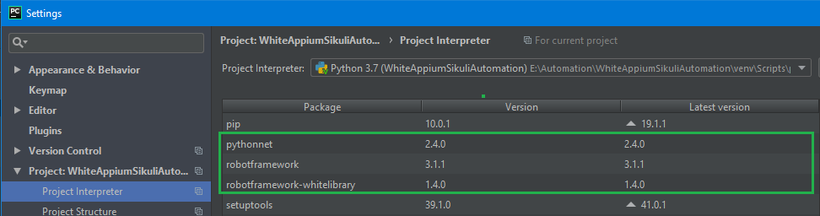

Step 3: Verify WhiteLibrary by composing and running a simple test case as follow:

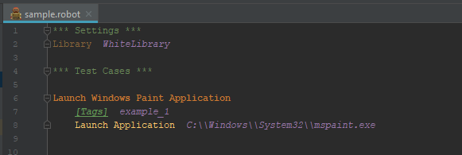

## 2. SikuliLibrary

Step 1: In an existing or new python project, open Terminal and execute following command:

pip install robotframework-SikuliLibrary

Step 2: Verify installed packages in Files > Settings: robotframework (if not) and robotframework-SikuliLibrary.

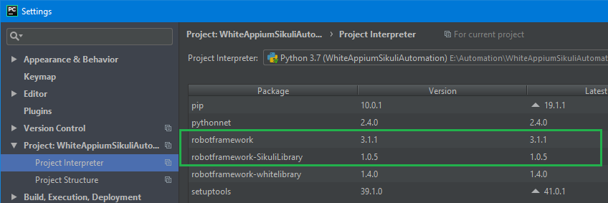

Step 3: Verify SikuliLibrary by composing and running a simple test case as follow:

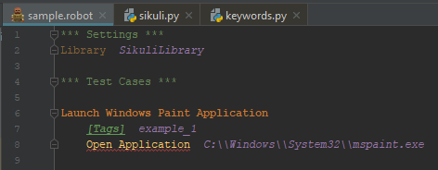

## 3. AppiumLibrary

Step 1: In an existing or new python project, open Terminal and execute following command:

pip install robotframework-appiumlibrary

Step 2: Verify installed packages in Files > Settings: robotframework (if not), kitchen, decorator, urllib3, selenium, six, docutils, Appium-Python-Client and robotframework-appiumlibrary.

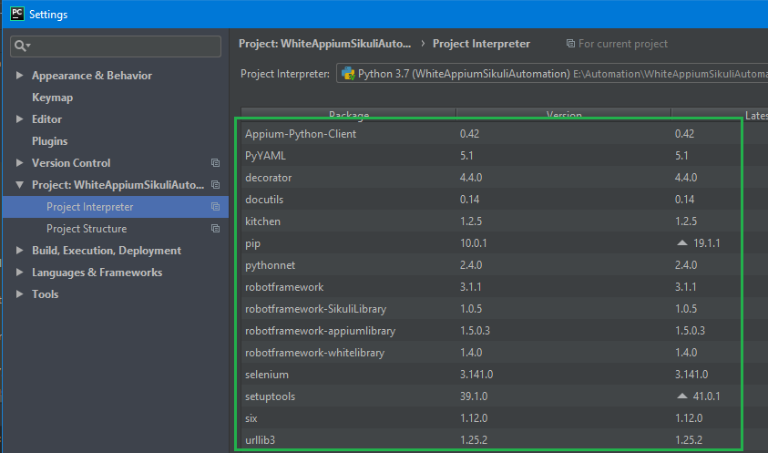

Step 3: Install Appium Desktop application by going to <https://github.com/appium/appium-desktop> and click on **Release** tab to download the latest version of Appium.

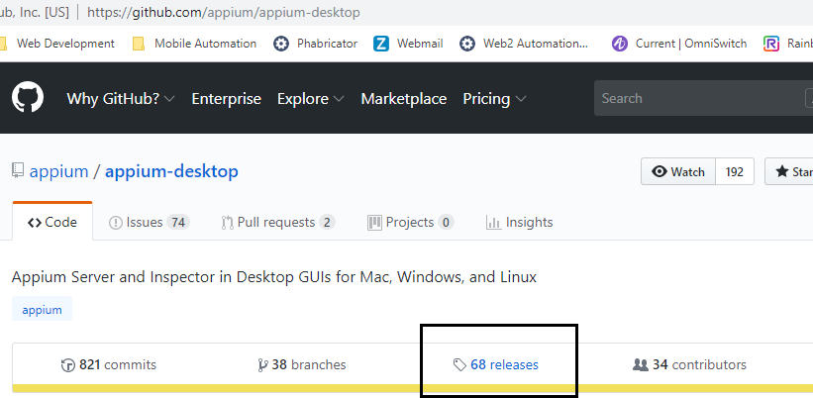

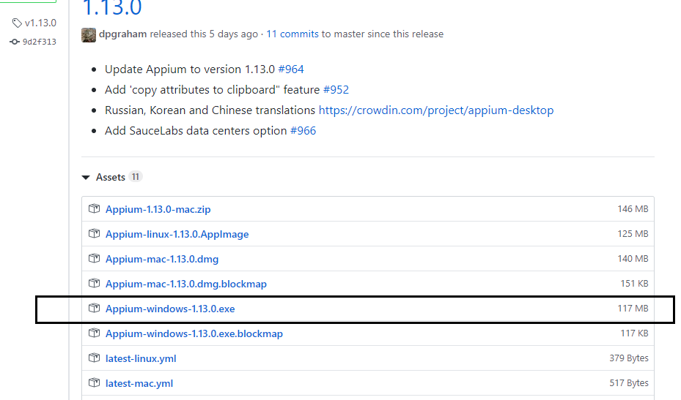

Step 4: Install Windows Application Driver (WinAppDriver) by going to <https://github.com/microsoft/WinAppDriver> and click on **Release** tab to download the latest version of WinAppDriver.

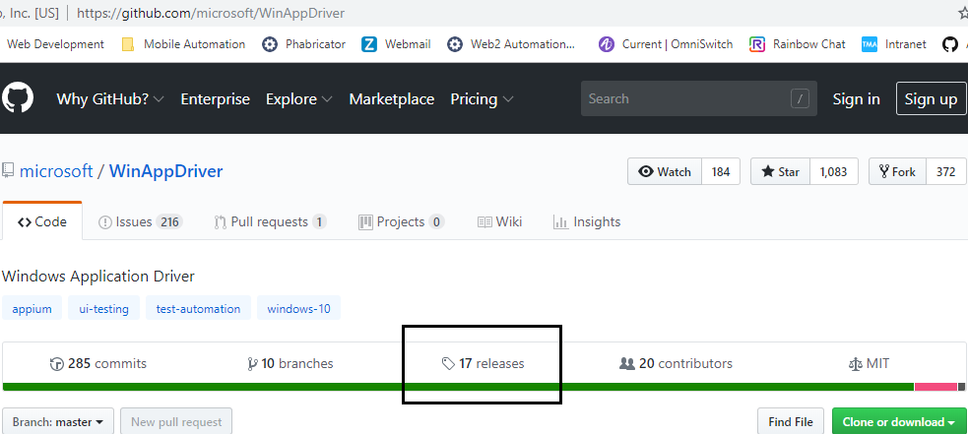

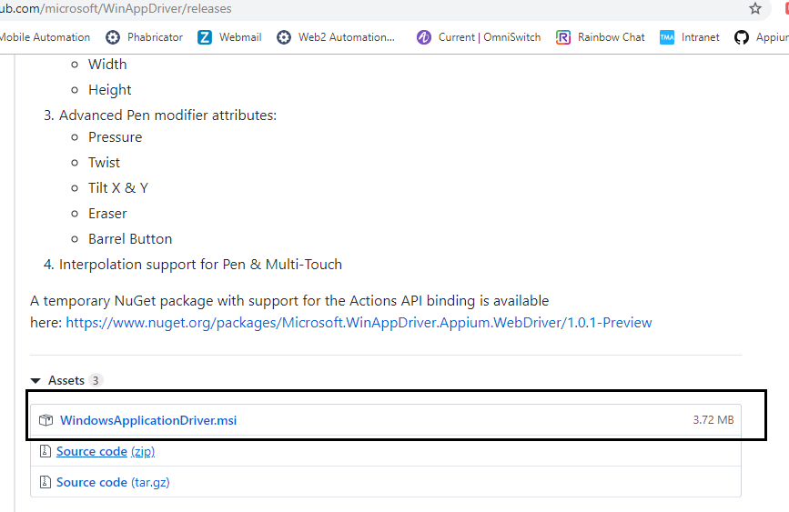

Step 5: Enable Developer mode on Windows by going to Settings:

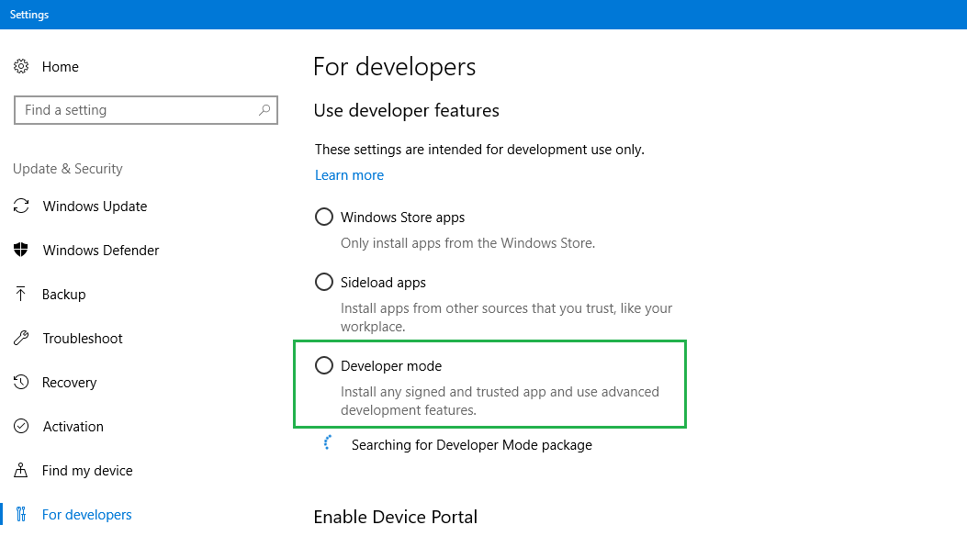

Step 6: Install Appium Desktop & WinAppDriver applications. Run Appium Desktop application and Start Server (default port is 4723).

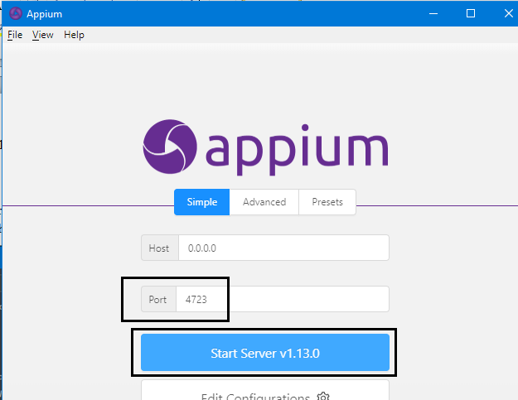

Step 7: Verify AppiumLibrary by composing and running a simple test case as follow:

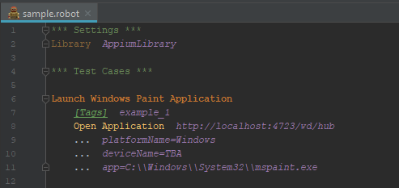

# Customization

## 1. SikuliLibrary